**Supplementary Material**

This supplementary material provides detailed explanations of some aspects of the experiment.

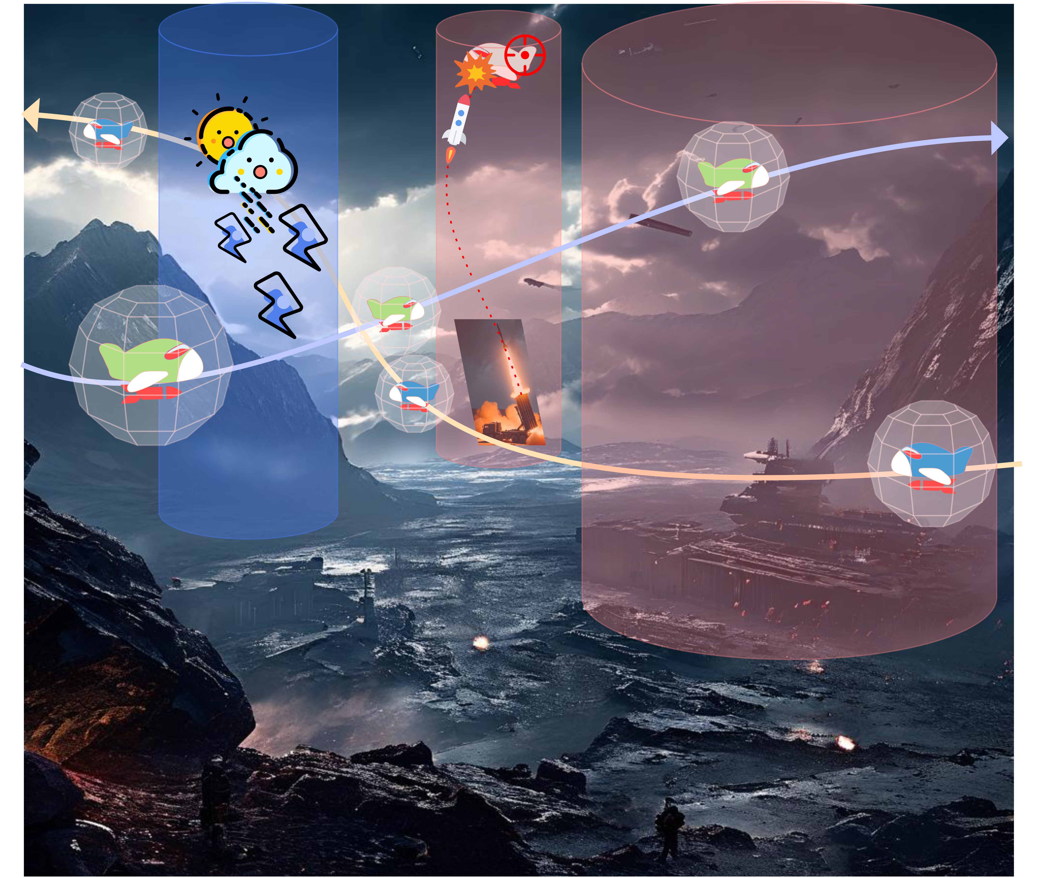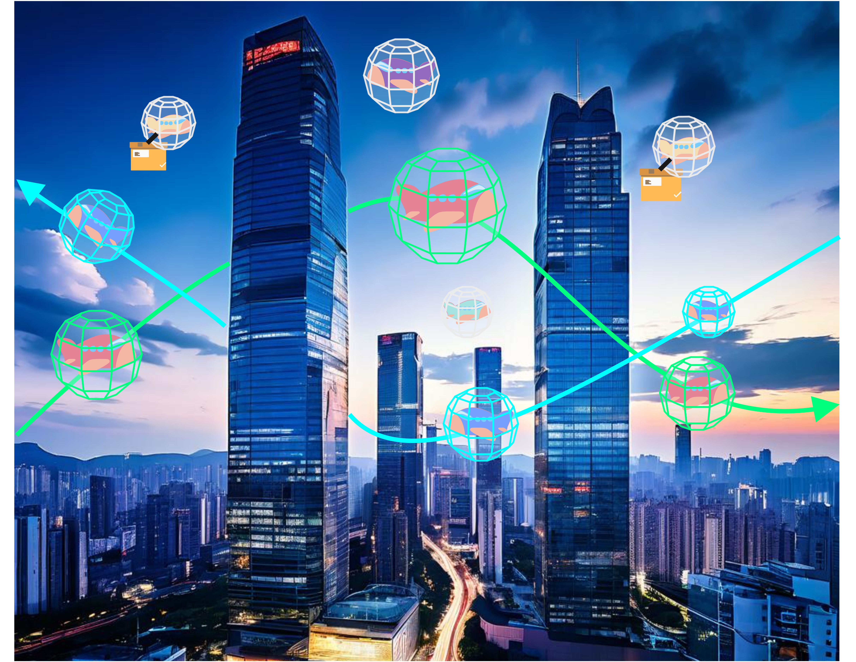

Fig. 1 Schematic of field combat scenario Fig. 2 Schematic of urban transportation scenario

This paper presents two experimental scenarios for UAV swarms. The first scenario (as in Fig. 1) is a field combat setting, characterized by plains, hills, and static obstacle areas simulating hazards like air defense radars. The second scenario (as in Fig. 2) involves urban transportation, featuring a flat terrain with numerous immovable buildings integrated into the terrain data. Scenario 2 poses greater challenges for the local path planner due to the increased terrain complexity, despite the absence of static obstacles. All experimental units are standardized, and the length unit is standardized as .

In Scenario 1, the horizontal extent of the experimental environment was set to ×, and the vertical extent was set to . The terrain environment was randomly generated with consistent data across all algorithms. The terrain data and generation algorithms can be downloaded from Supplementary Materials. A 3D view is presented in Fig. 3.

Table 1 Information about the 13 static obstacles in Scenario 1

|  |  |  |  |  |  |  |  |  |  |  |  |  |  |
| --- | --- | --- | --- | --- | --- | --- | --- | --- | --- | --- | --- | --- | --- |
| *id* | 1 | 2 | 3 | 4 | 5 | 6 | 7 | 8 | 9 | 10 | 11 | 12 | 13 |
|  | 102.6 | 102.6 | 410.4 | 410.4 | 179.55 | 179.55 | 333.45 | 333.45 | 256.5 | 256.5 | 256.5 | 410.4 | 102.6 |
|  | 410.4 | 102.6 | 102.6 | 410.4 | 333.45 | 179.55 | 184.68 | 333.45 | 256.5 | 410.4 | 102.6 | 256.5 | 256.5 |
|  | 15.39 | 15.39 | 15.39 | 15.39 | 15.39 | 15.39 | 15.39 | 15.39 | 15.39 | 15.39 | 15.39 | 15.39 | 15.39 |

We created an experimental environment with 13 static cylindrical obstacle regions to simulate flight exclusion zones, as shown in Fig. 3. Each obstacle has a known radius and infinite height, with a safety distance equal to the body radius of 3. Their positions and sizes are detailed in Table 1.

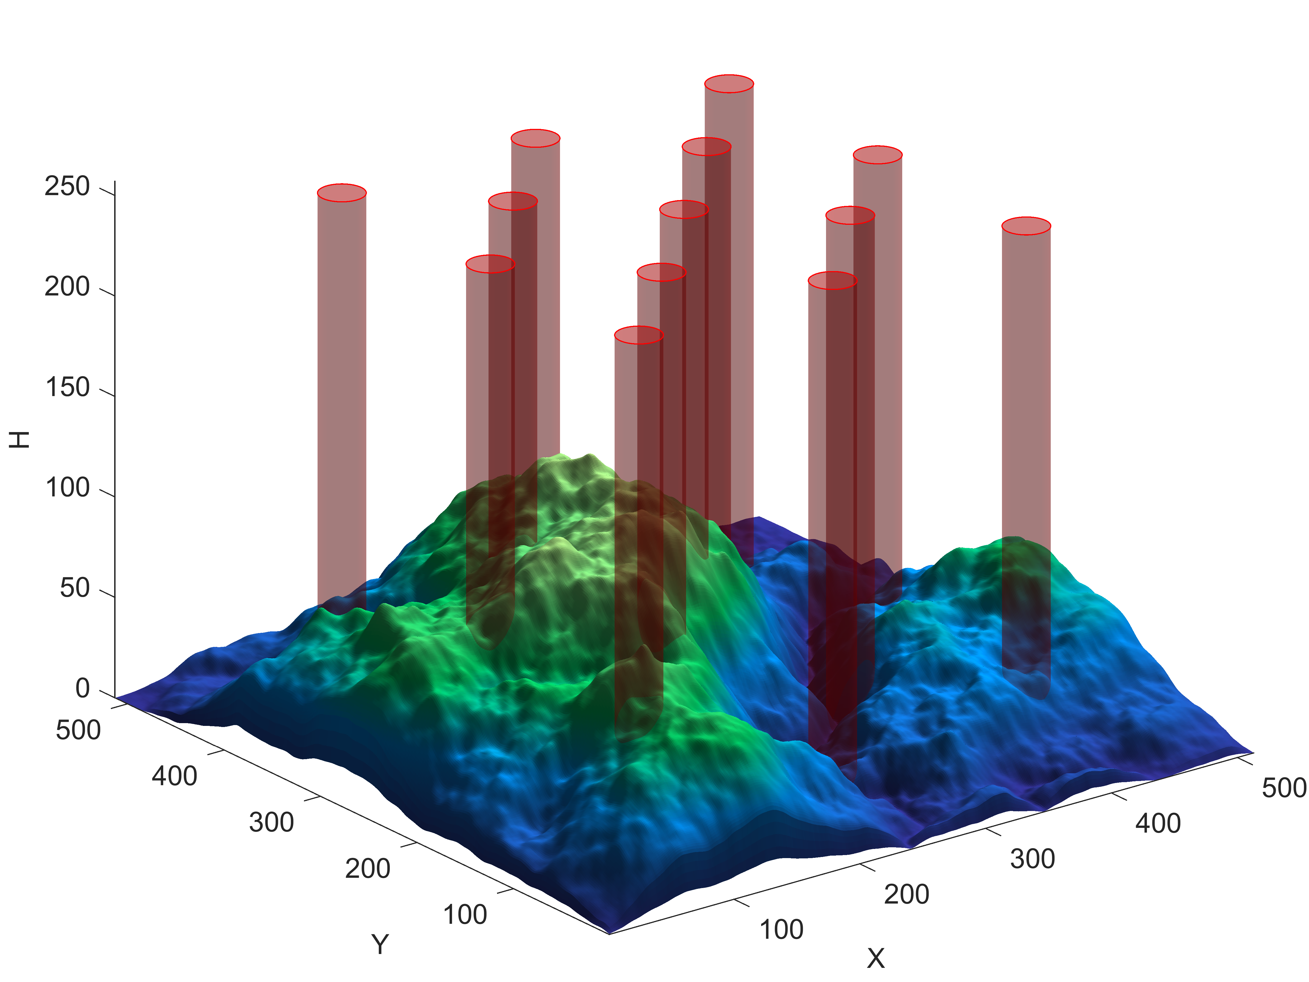 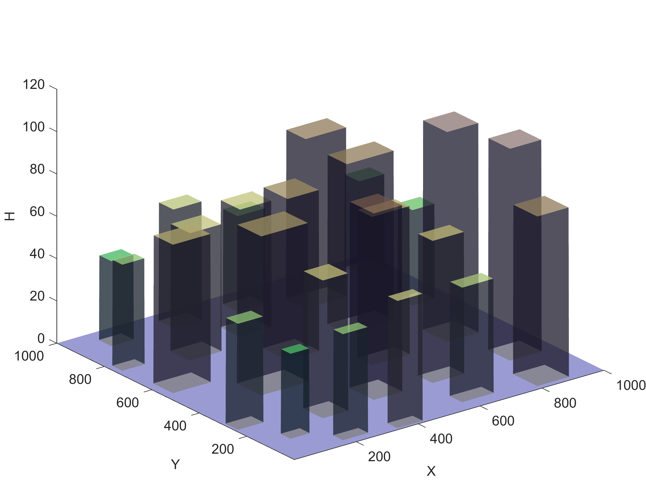

Fig. 3 3D view of field combat scenario Fig. 4 3D view of urban transportation scenario

In Scenario 2, the horizontal extent of the experimental environment was set to × and the vertical extent was set to . The terrain environment was randomly generated with the same terrain data for all algorithms, and the terrain data is available for download at Supplementary Materials. A 3D view of the terrain is shown in Fig. 4.

The experimental environment features several UAVs. In Scenario 1, the UAV radius is 3, which is sufficient to simulate various real-life products. For the larger map in Scenario 2, the UAV radius is increased to 5. The pitch angle of all the UAVs is maximized to , the flying turn direction is set to omnidirectional, and the magnitude of the velocity per unit of time to .

In Scenario 2, integrating building information with terrain reveals significant undulations, increasing the risk of UAV collisions with the terrain. As illustrated in Fig. 5, part of the UAV's reference ball may already penetrate the building despite it being elevated from the ground. To prevent this, we preprocess the DGM model matrices using a maximal mask to expand the building’s footprint horizontally, thus reducing collision risks. This is demonstrated in Fig. 6, which shows the unprocessed terrain on the left and the significantly enlarged processed terrain on the right.



Fig. 5 Threats and solutions due to undulating terrain Fig. 6 Maximum mask expanding the terrain

According to the description of the PSCM process in Section 3, each UAV generates local paths in sequence and places temporary obstacle regions in space, so the difficulties of path planning increase with the number of UAVs.

To enable a fair measure of the ability of various optimization algorithms to optimize the dynamic local path planner for this UAV swarm, we separated the process and compared the performance strength of various local path search algorithms by counting the path of the th UAV ( abbreviated as test UAV, described in detail in the next sentence) in multiple iterations based on controlling the same path of the first  UAV ( abbreviated as interference UAVs, described in detail in the next sentence) , as shown in Fig. 7.

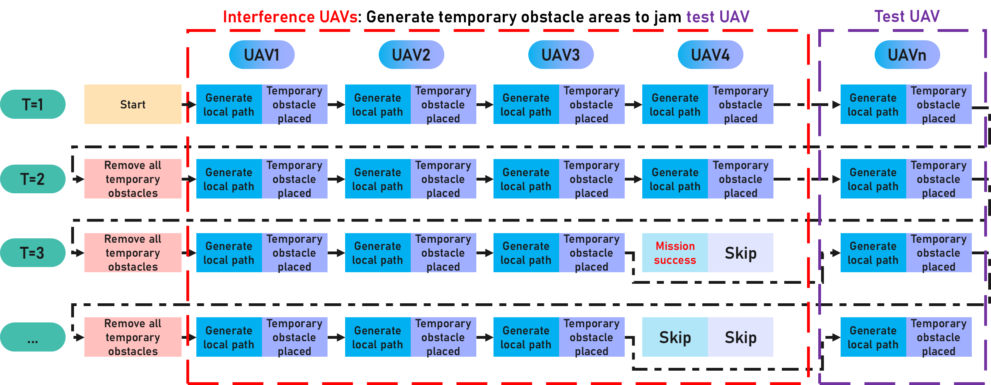

Fig. 7 Schema of the principles of the scenario simulation experiment

The UAVs in the solution region are divided into two kinds, one is the interference UAVs, these UAVs fly back and forth between the regions along different straight lines, which are used to interfere with the newly generated local paths of the UAVs, and the other is the test UAVs, which plan the local paths independently in each time period according to the environmental information and the paths of the UAVs, and record their trace information in real time, which is used to test the planning ability of the local path search algorithm.

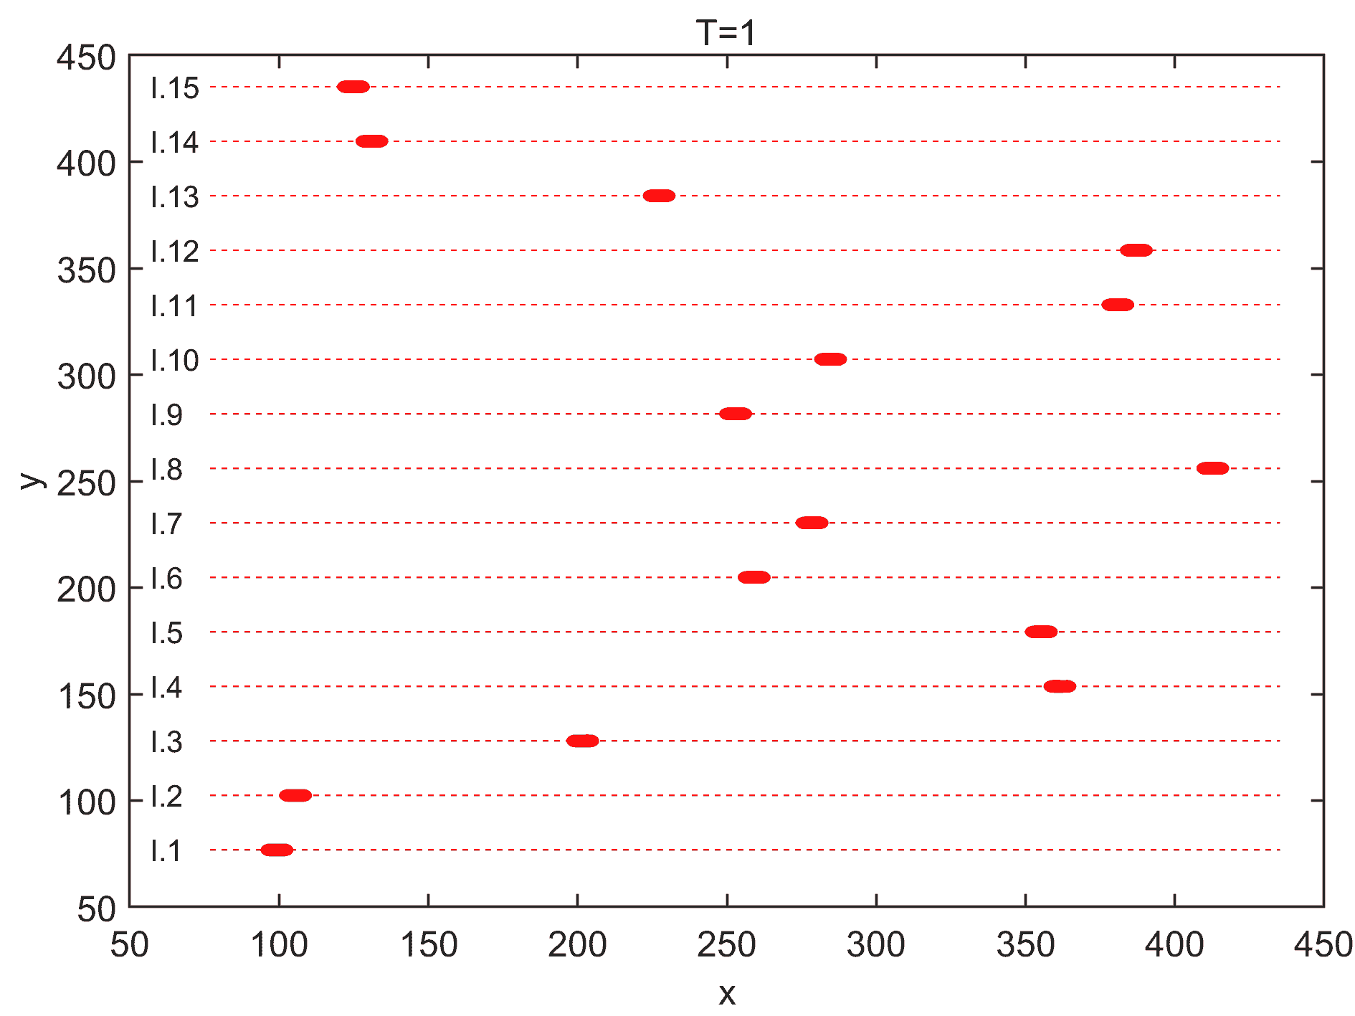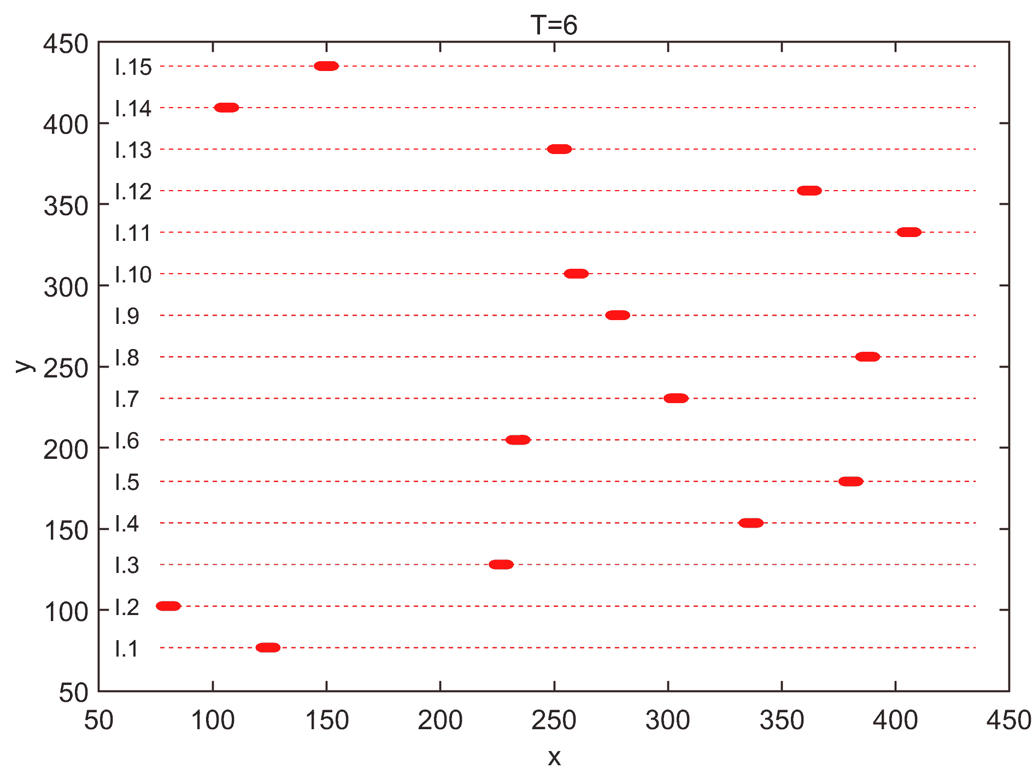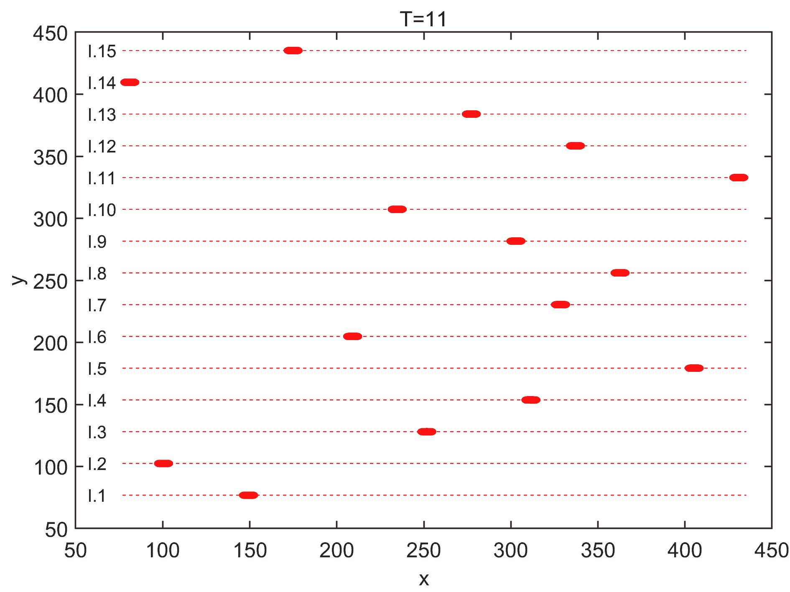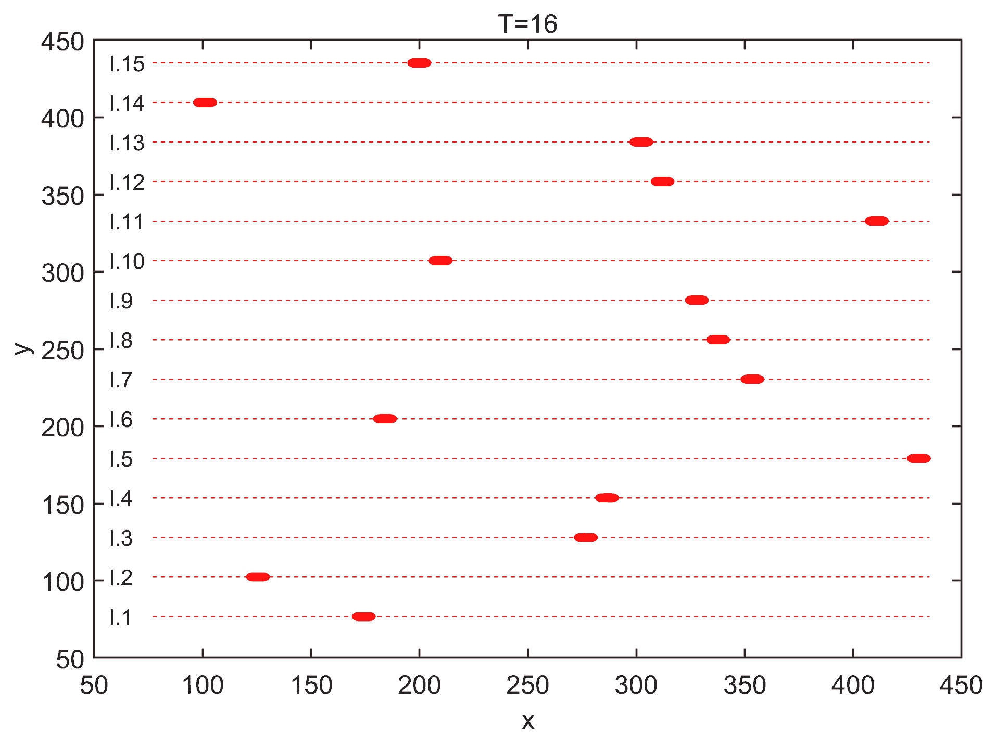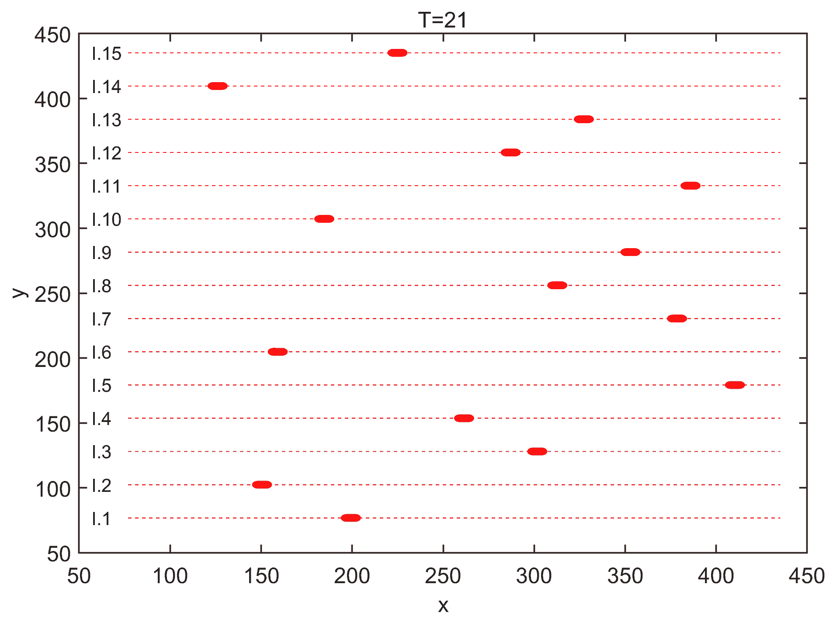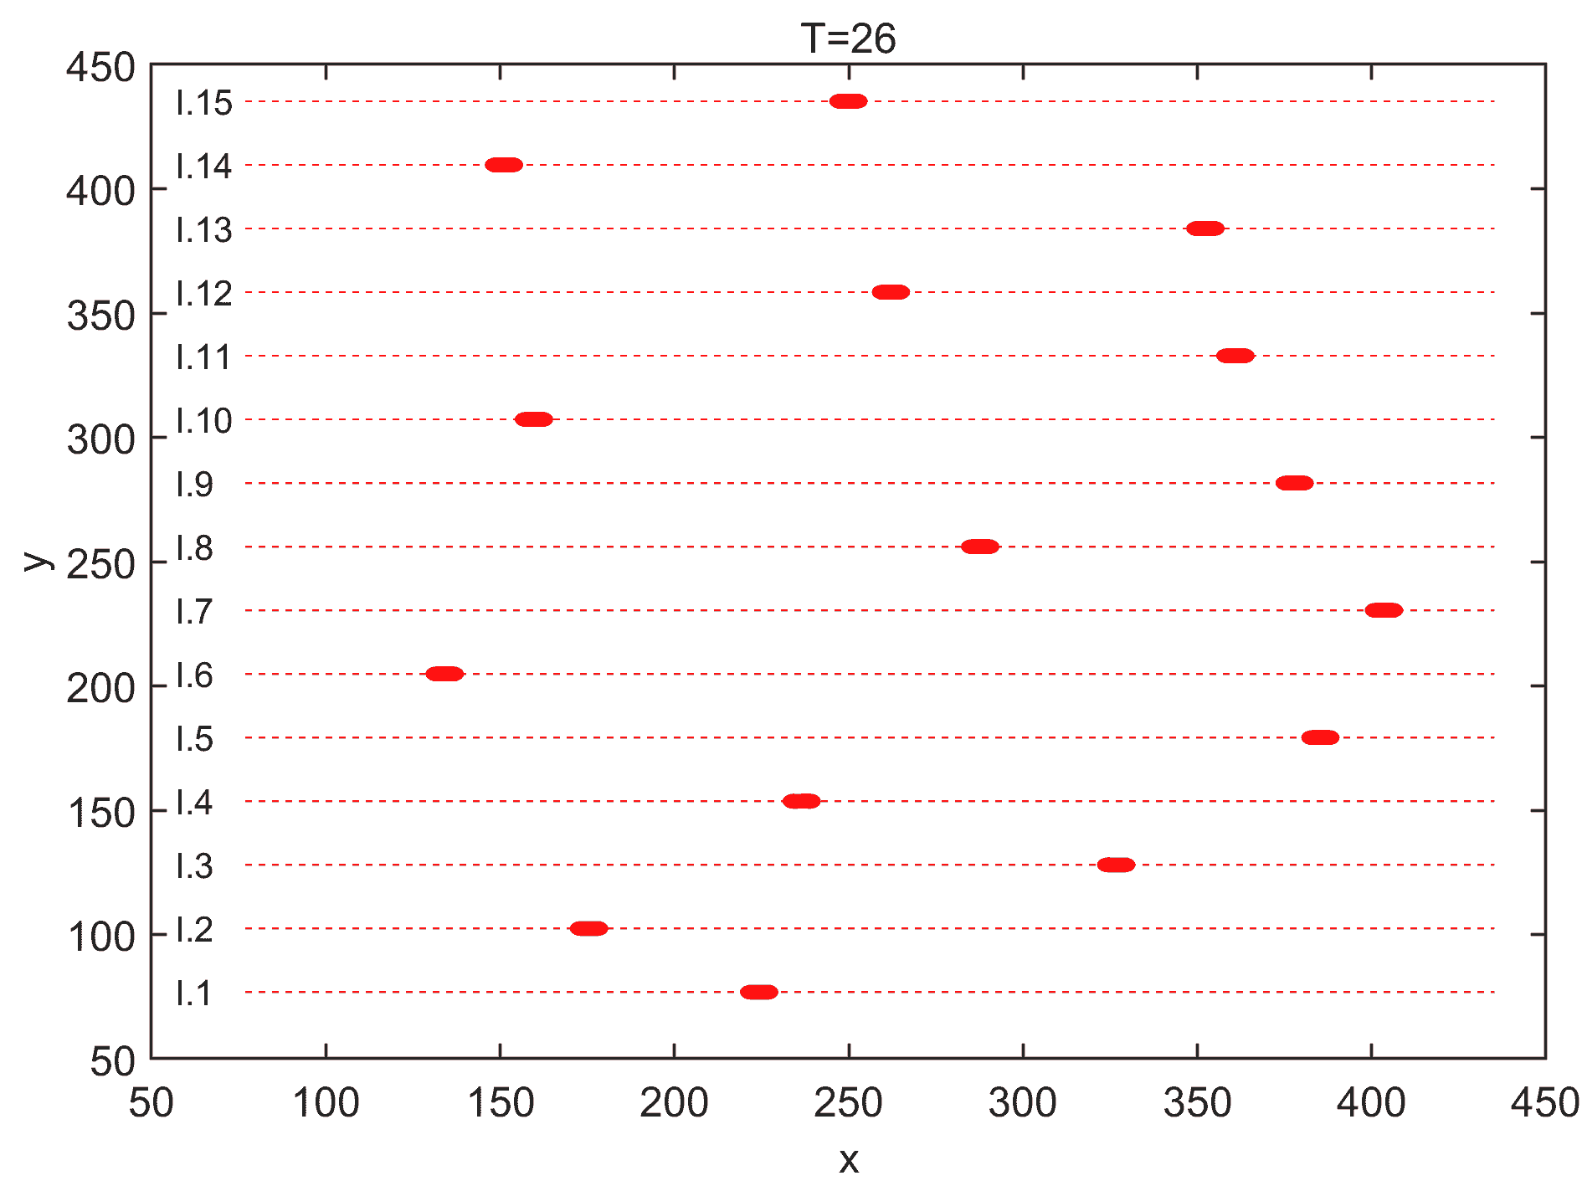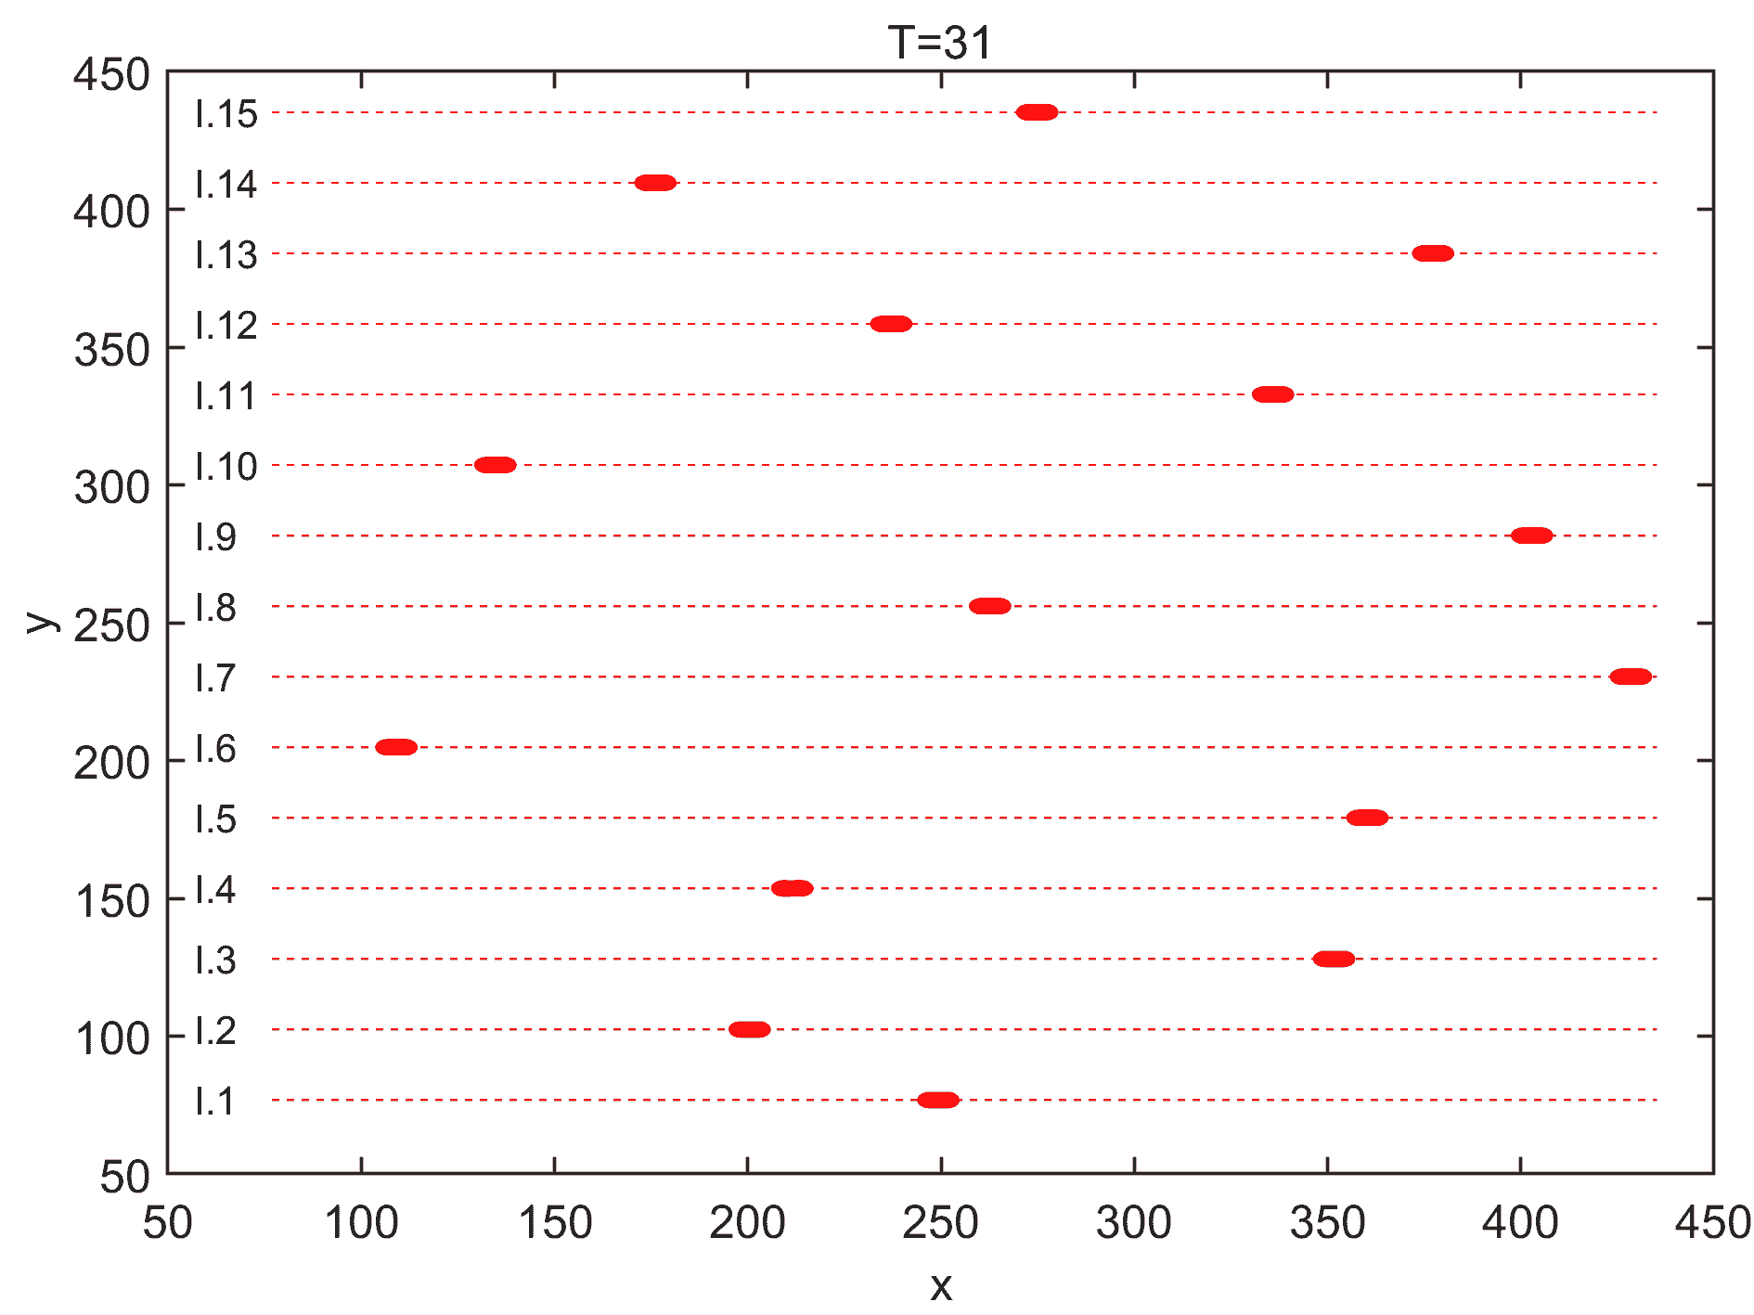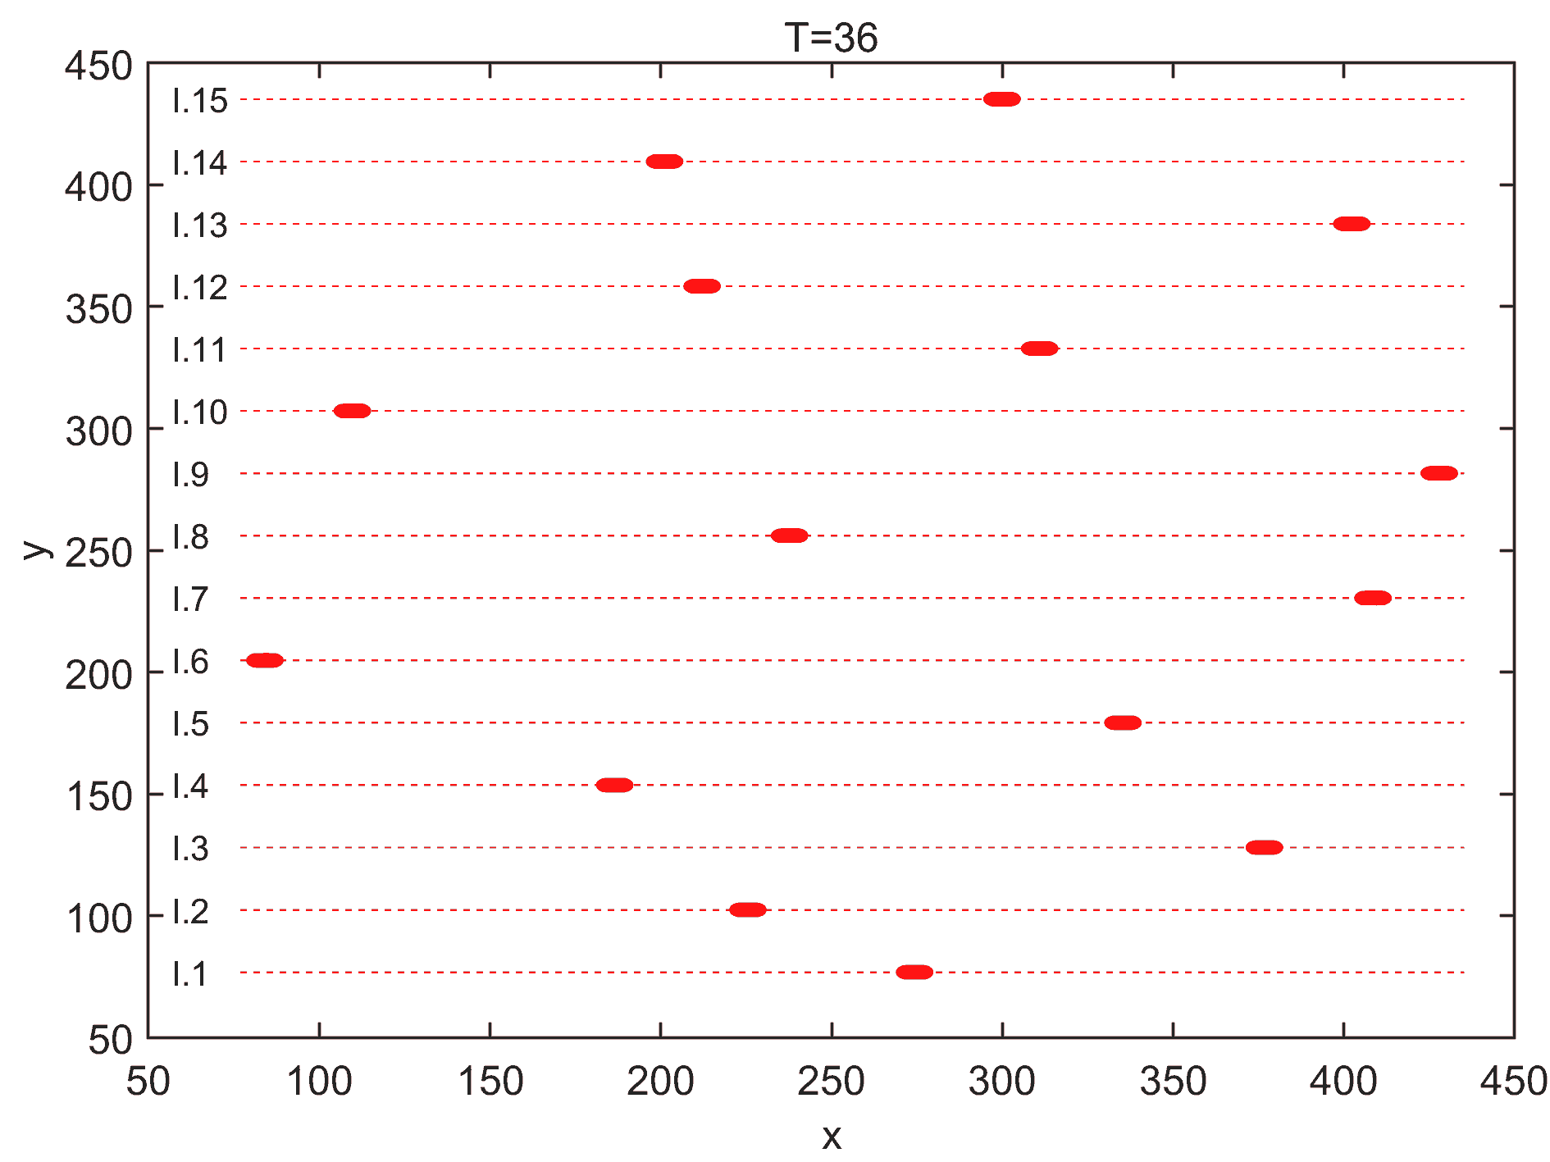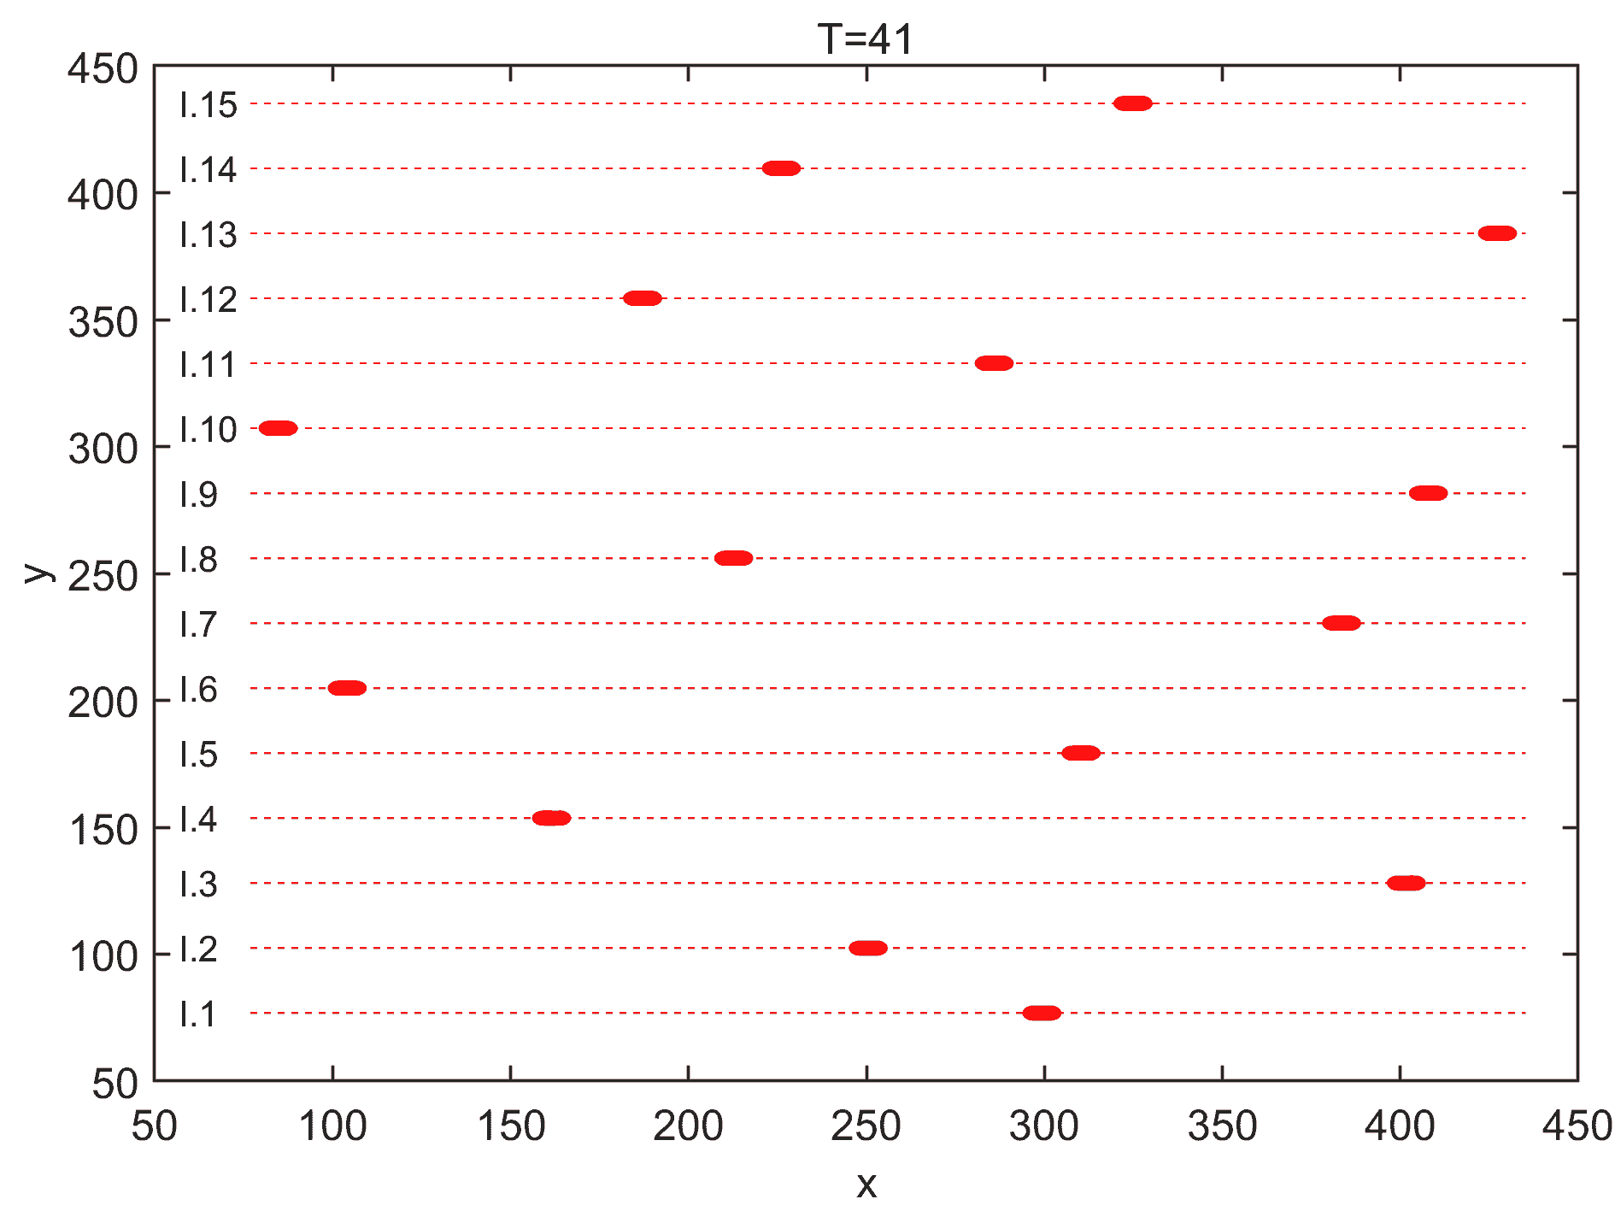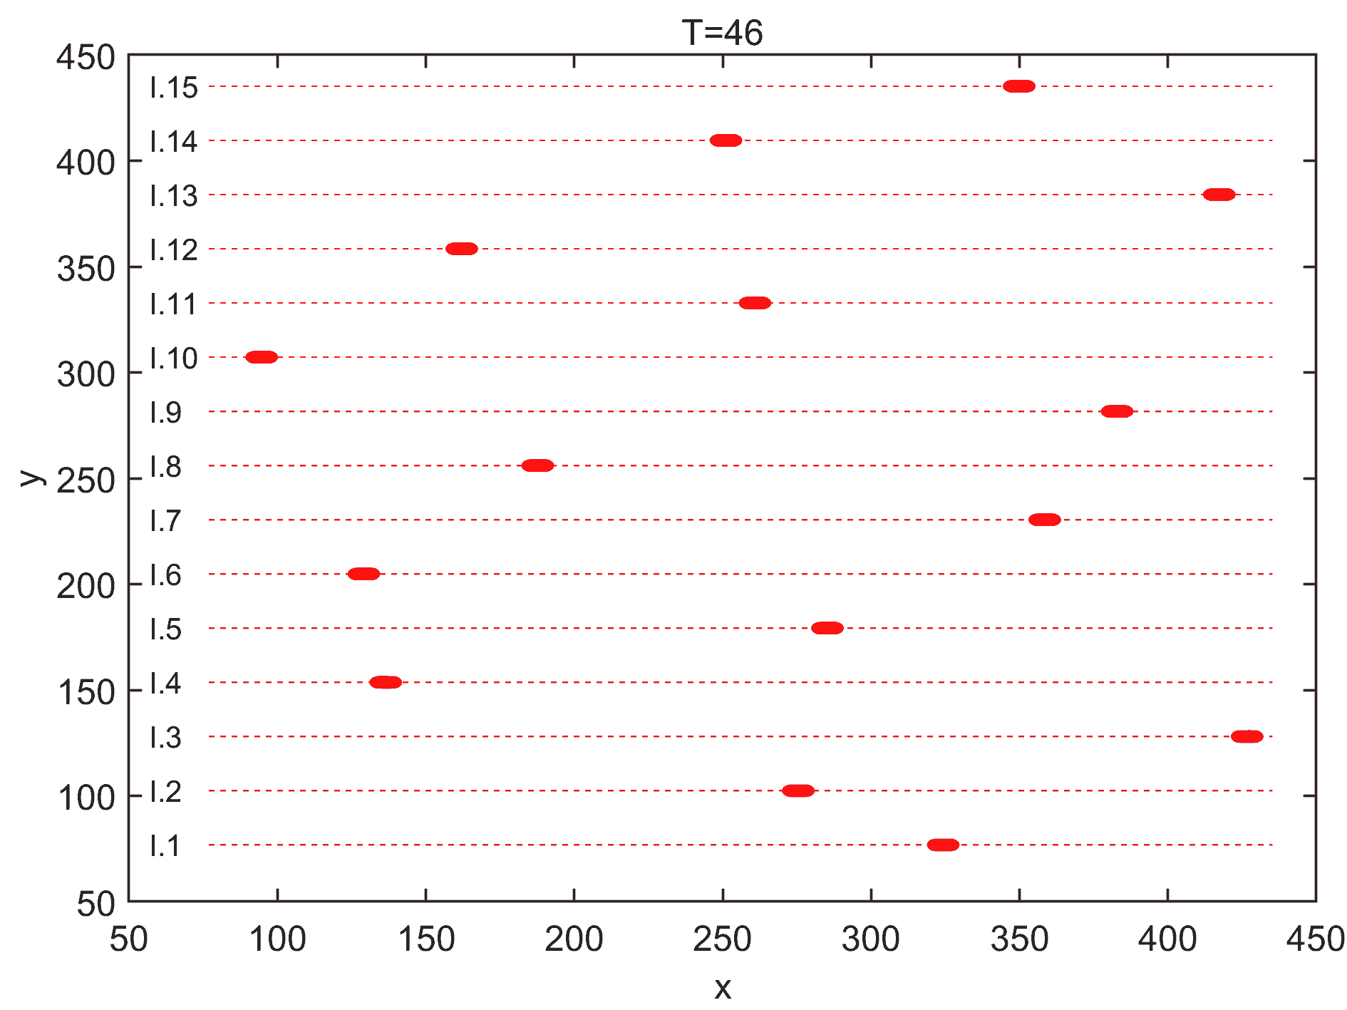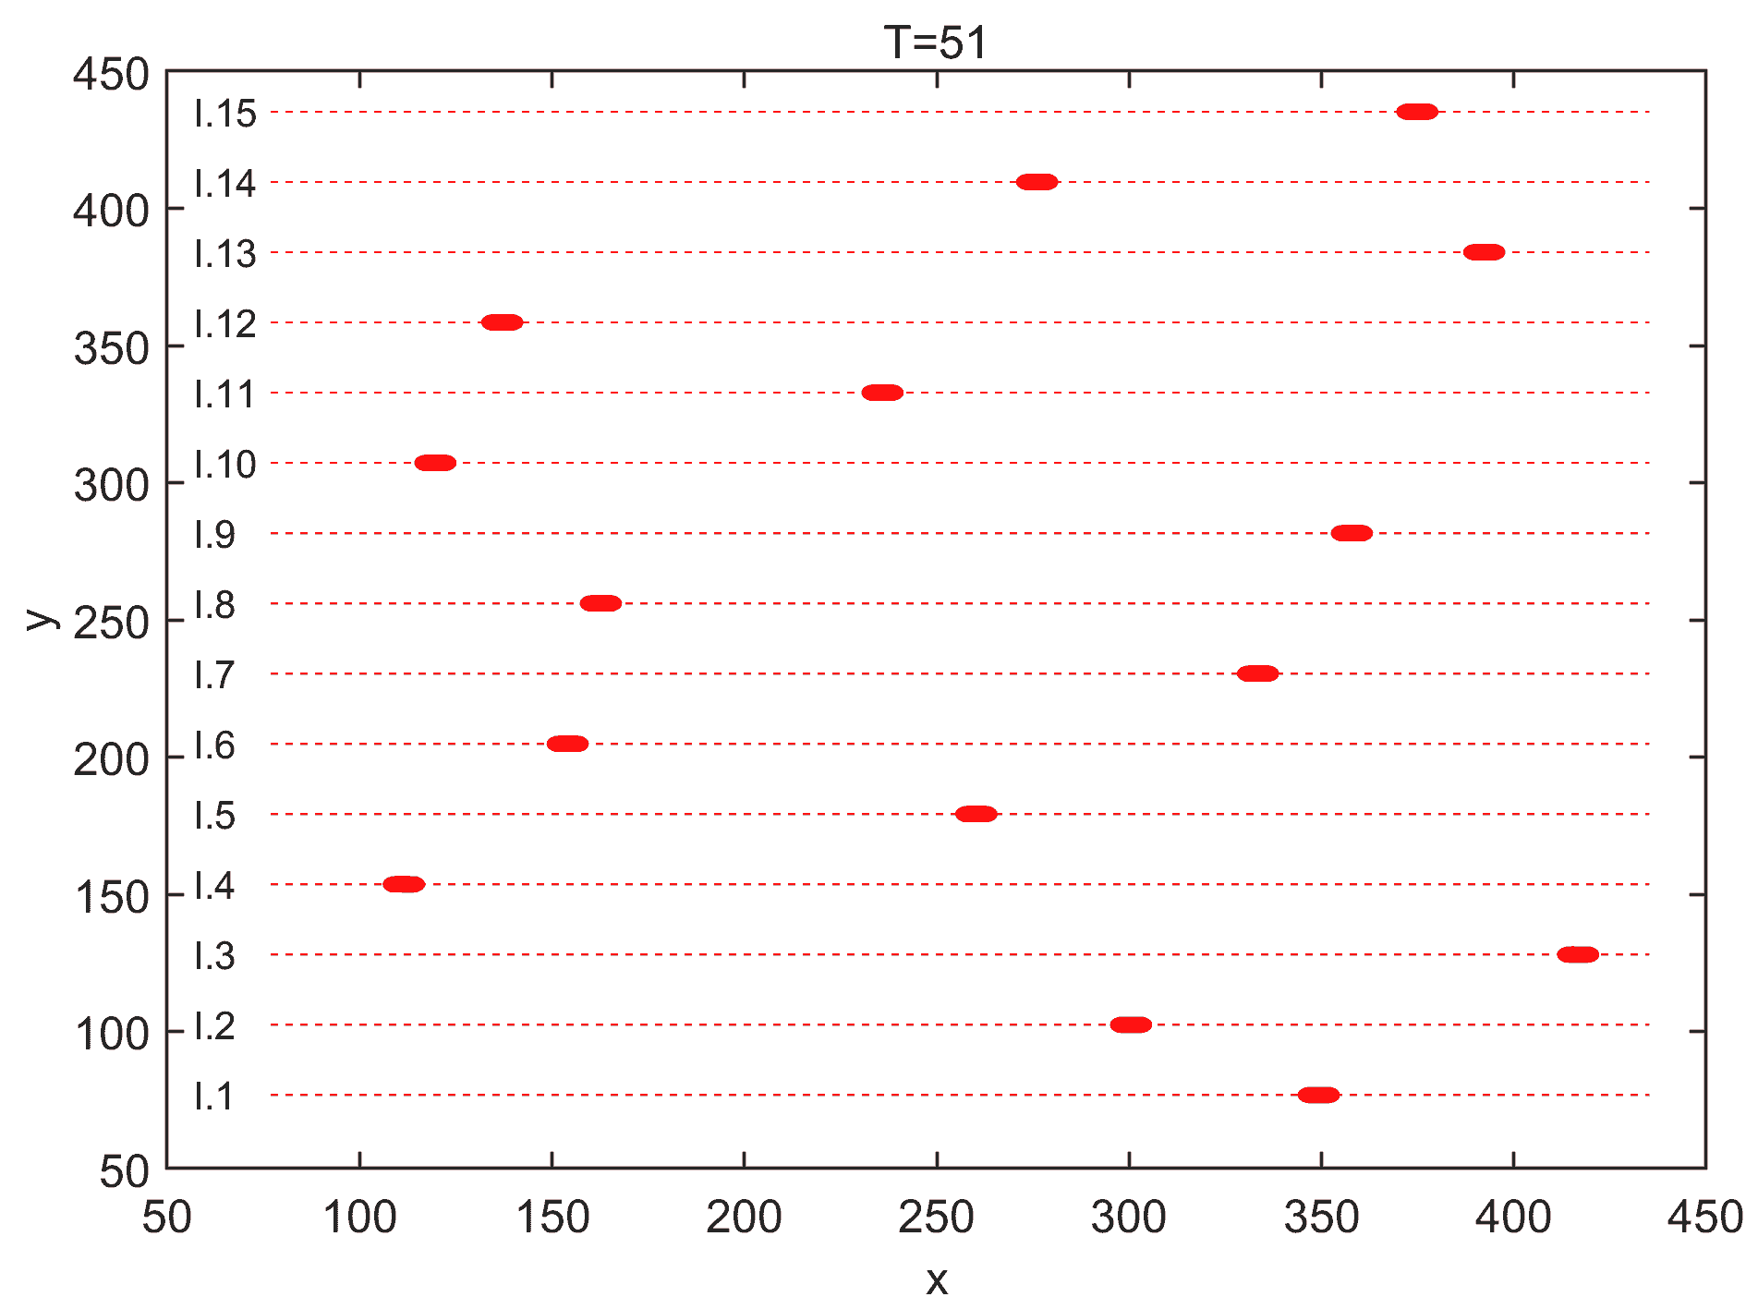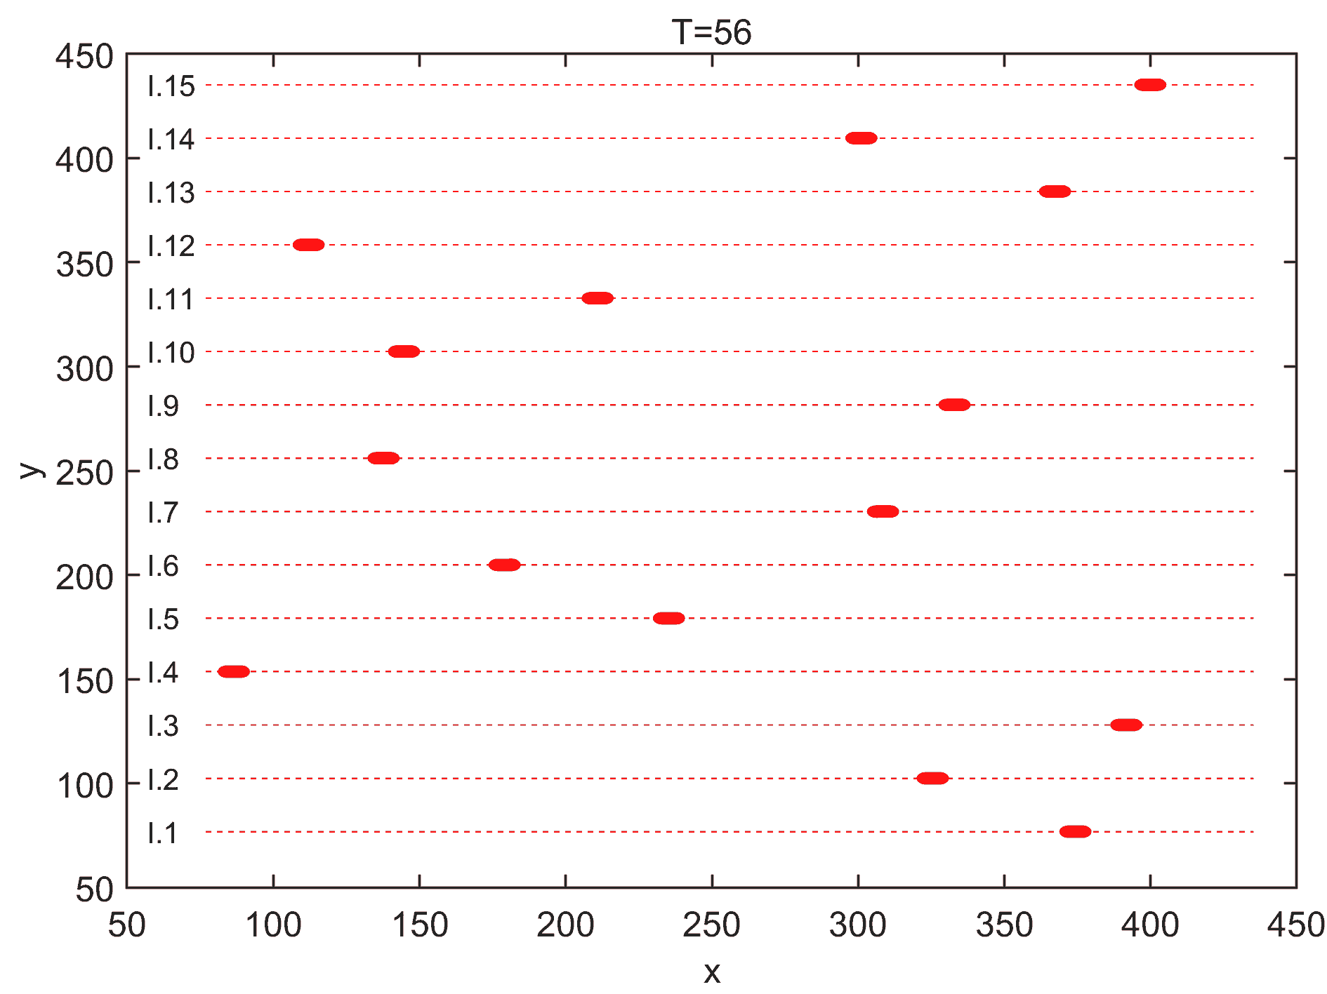

Fig. 8 Top view of interference in Scenario 1

There are 15 interference UAVs designed to maximize their impact on test UAVs by flying nearly perpendicular to their direction. Each jamming UAV starts at a fixed speed and reverses its direction if it's likely to exceed a preset limit. Fig. 8 illustrates the flight paths of the interfering UAVs in Scenario 1, showing 12 recorded trails at 5 time intervals. The red dashed lines represent the UAV trajectories, while the red solid areas indicate the temporary static obstacles created by each UAV during this period. Table 2 provides the relevant information about the 15 interfering UAVs in Scenario 1 and Scenario 2.

The map features multiple sets of starting and ending points, with each set representing a mission. Each scenario includes four distinct missions. To maximize interference from the UAVs, the interference UAVs fly nearly perpendicular to the test UAVs. In Scenario 1, the interference UAVs are positioned at varying heights between  in a wavy pattern, while mission heights are uniform at 100. The vertical relationship between interference UAVs and missions is illustrated in Fig. 9 (taking Scenario 1 as an example), where the blue dashed line shows the projection of mission start points on the x-plane, and the red ball represents the unchanged projection of the interfering UAV.

Table 2 Information about the interfering UAVs in Scenario 1 and Scenario 2

|  |  |  |  |  |  |  |  |  |  |
| --- | --- | --- | --- | --- | --- | --- | --- | --- | --- |
| Scenario 1:battlefield in the wilderness | | | | | Scenario 2:urban transportation | | | | |
| IUAV | Starting Position | Velocity | One Boundary | Another Boundary | IUAV | Starting Position | Velocity | One Boundary | Another Boundary |
| I.1 | [76.80,76.80,80] | [5,0,0] | [76.80,76.80,80] | [435.200,76.80,80] | I.1 | [150,150,40] | [15,0,0] | [76.800,150,40] | [435.20,150,40] |
| I.2 | [128,102.400,100] | [-5,0,0] | [76.80,102.400,100] | [435.200,102.400,100] | I.2 | [250,200,50] | [-15,0,0] | [76.800,200,50] | [435.20,200,50] |
| I.3 | [179.200,128,120] | [5,0,0] | [76.80,128,120] | [435.200,128,120] | I.3 | [350,250,60] | [15,0,0] | [76.800,250,60] | [435.20,250,60] |
| I.4 | [384,153.600,120] | [-5,0,0] | [76.80,153.600,120] | [435.200,153.600,120] | I.4 | [750,300,60] | [-15,0,0] | [76.800,300,60] | [435.20,300,60] |
| I.5 | [332.800,179.200,100] | [5,0,0] | [76.80,179.200,100] | [435.200,179.200,100] | I.5 | [650,350,50] | [15,0,0] | [76.800,350,50] | [435.20,350,50] |
| I.6 | [281.600,204.800,80] | [-5,0,0] | [76.80,204.800,80] | [435.200,204.800,80] | I.6 | [550,400,40] | [-15,0,0] | [76.800,400,40] | [435.20,400,40] |
| I.7 | [256,230.400,80] | [5,0,0] | [76.80,230.400,80] | [435.200,230.400,80] | I.7 | [500,450,40] | [15,0,0] | [76.800,450,40] | [435.20,450,40] |
| I.8 | [435.200,256,100] | [-5,0,0] | [76.80,256,100] | [435.200,256,100] | I.8 | [850,500,50] | [-15,0,0] | [76.800,500,50] | [435.20,500,50] |
| I.9 | [230.400,281.600,120] | [5,0,0] | [76.80,281.600,120] | [435.200,281.600,120] | I.9 | [450,550,60] | [15,0,0] | [76.800,550,60] | [435.20,550,60] |
| I.10 | [307.200,307.200,120] | [-5,0,0] | [76.80,307.200,120] | [435.200,307.200,120] | I.10 | [600,600,60] | [-15,0,0] | [76.800,600,60] | [435.20,600,60] |
| I.11 | [358.400,332.800,100] | [5,0,0] | [76.80,332.800,100] | [435.200,332.800,100] | I.11 | [700,650,50] | [15,0,0] | [76.800,650,50] | [435.20,650,50] |
| I.12 | [409.600,358.400,80] | [-5,0,0] | [76.80,358.400,80] | [435.200,358.400,80] | I.12 | [800,700,40] | [-15,0,0] | [76.800,700,40] | [435.20,700,40] |
| I.13 | [204.800,384,80] | [5,0,0] | [76.80,384,80] | [435.200,384,80] | I.13 | [400,750,40] | [15,0,0] | [76.800,750,40] | [435.20,750,40] |
| I.14 | [153.600,409.600,100] | [-5,0,0] | [76.80,409.600,100] | [435.200,409.600,100] | I.14 | [300,800,50] | [-15,0,0] | [76.800,800,50] | [435.20,800,50] |
| I.15 | [102.400,435.200,120] | [5,0,0] | [76.80,435.200,120] | [435.200,435.200,120] | I.15 | [200,850,60] | [15,0,0] | [76.800,850,60] | [435.20,850,60] |

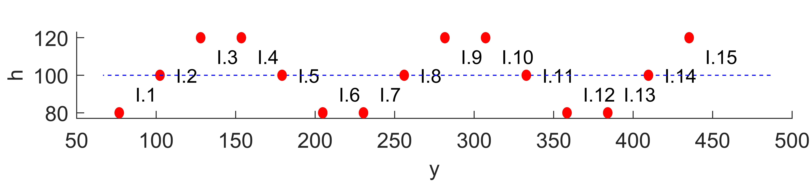

Fig. 9 Side view of the path of the interfering UAVs in Scenario 1 with the mission linkage

Table 3 Information about the missions in Scenario 1 and Scenario 2

|  |  |  |  |  |  |  |
| --- | --- | --- | --- | --- | --- | --- |
| Scenario | Mission | Mission Start Point | Mission End Point | TUAV.id | Mission Distance | Mission time limit |
| Battlefield in the wilderness | Missions 1 | [102.60,51.30,100] | [307.80,461.70,100] | 1 5 9 13 17 ... 105 109 113 117 | 458.841 | 100 |
| Missions 2 | [205.20,51.30,100] | [410.40,461.70,100] | 2 6 10 14 18 ... 106 110 114 118 | 458.841 | 100 |
| Missions 3 | [307.80,51.30,100] | [205.20,461.70,100] | 3 7 11 15 19 ... 107 111 115 119 | 423.030 | 100 |
| Missions 4 | [410.40,51.30,100] | [102.60,461.70,100] | 4 8 12 16 20 ... 108 112 116 120 | 513.000 | 100 |
| Urban transportation | Missions 1 | [50,950,40] | [560,130,40] | 1 5 9 13 17 ... 105 109 113 117 | 965.660 | 200 |
| Missions 2 | [950,850,40] | [350,150,40] | 2 6 10 14 18 ... 106 110 114 118 | 921.954 | 200 |
| Missions 3 | [750,100,40] | [200,950,40] | 3 7 11 15 19 ... 107 111 115 119 | 1012.422 | 200 |
| Missions 4 | [950,50,40] | [450,950,40] | 4 8 12 16 20 ... 108 112 116 120 | 1029.563 | 200 |

To minimize the effect of random factors, each path-planning algorithm independently conducts 30 repetitive experiments; that is, 30 identical UAVs are used to implement the same mission simultaneously, and their position information at each moment is recorded independently to analyze the path-planning results. Table 3 shows the information related to the four missions and the 120 test UAVs. In Scenario 2, the altitude of the interfering UAV is located between , the altitude of the city ground is set to 0,  to 20, and the mission altitude is set to 40; this altitude can let the floors with smaller heights influencing the UAVs on one hand, and on the other hand it can also check the effect of the adjustment of the  for the path of the UAVs.

The default values of the other parameters in Section 4 are shown in Table 4, where "or" indicates the different values in the two scenarios in the later experiments.

Table 4 The default values of the other parameters in Section 4

|  |  |  |  |  |  |
| --- | --- | --- | --- | --- | --- |
| Section | Name | Value | Section | Name | Value |
| 4.3 |  | 20m | 4.5 |  | 0 |
| 4.4 |  | 13 | 4.5 |  | 256 or 120 |
| 4.4 |  | 1 | 4.6 |  | 3 |
| 4.5 |  | 1 or 0 | 4.7 |  | 0.5 |
| 4.5 |  | 513 or 1000 | 4.7 |  | 10 |
| 4.5 |  | 1 or 0 | 4.7 |  | [0.02,0.02,0.02,0.02,0.02,0.002,0.002,0.002,0.002,0.002] |
| 4.5 |  | 513 or 1000 | 4 |  | 5000 |